Take-home test 2 - Gideon Ngetich

Task 1: Usability Review (QA Mindset + Curiosity)

What works well from users’ perspective:
- The bottom tab bar (Home, Reels, Activity, Search, Profile) offers consistent, one-tap access to core features.
- Reels and Stories load quickly with minimal buffering, even on moderate connections.
- Effective Search Functionality: Instant results as you type and Recent search persistence with easy clearing.

What 3 quality risks or UX problems could negatively affect the user experience?
- One quality risk on Instagram is the lack of intuitive video controls. For example, when a user taps the center of a Reel or video, it doesn’t pause as most users expect, instead, the video continues playing and gets muted. This breaks common user expectations and leads to confusion, especially for new users who are used to tap-to-pause behavior in other apps. Illustration is shown in figure 1 below.

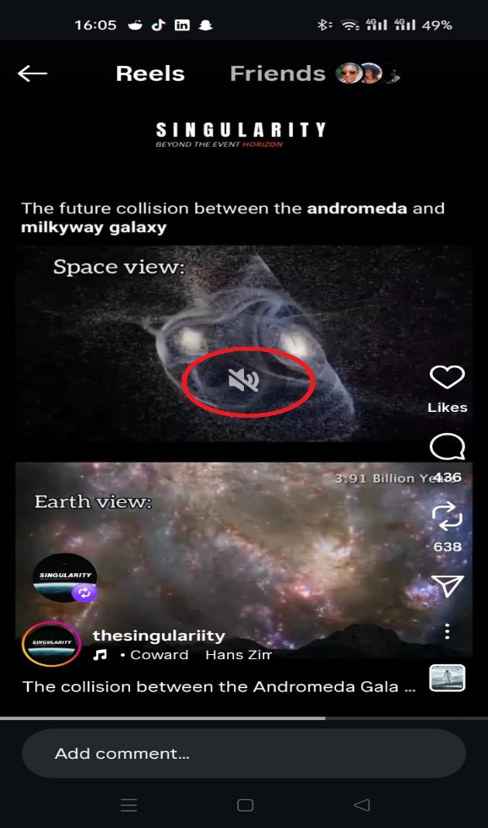
Figure 1

- Another UX issue is automatic muting of videos on app launch. When users open Instagram, videos and Reels often start muted by default, requiring the user to manually unmute every time. This can be frustrating, particularly when users intentionally open the app to watch content with sound, and it reduces engagement. Illustration is shown in figure 2 below.

Figure 2

- There is also a poor feedback mechanism in Direct Messages when offline. If a user tries to send a message without an internet connection, the message stays in a “sending…” state instead of clearly informing the user that mobile data or Wi-Fi is off. This creates uncertainty and wastes user time, as they may assume the app is working when it’s actually a connectivity issue. Illustration is shown in figure 3 below.
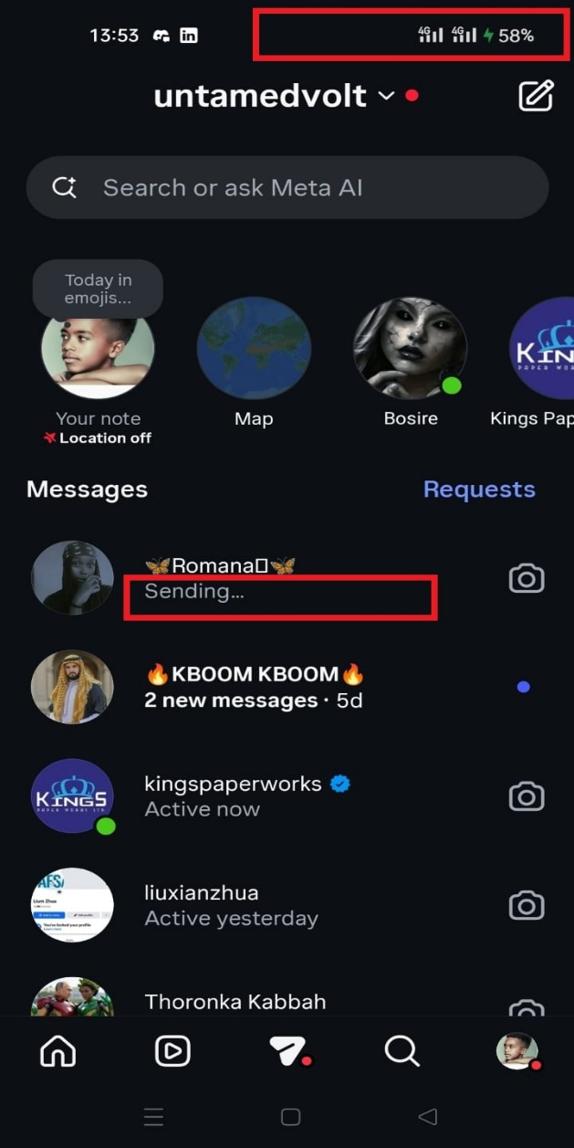
Figure 3

How would you prioritize these risks (High/Medium/Low), and why?
High: Poor Feedback When Sending DMs While Offline
This directly affects core communication functionality. When a message stays on “sending…” without telling the user they’re offline, users are misled into thinking the app is working. It causes message delays, confusion, and loss of trust, especially in time-sensitive conversations. Because it impacts reliability and clarity, this is a high-priority UX risk.
Medium: Unintuitive Video Controls (Tap to Mute Instead of Pause)
This breaks common user expectations. Most users expect tapping the center of a video to pause, not mute or continue playing. While it doesn’t stop users from consuming content, it causes frustration and repeated incorrect interactions. Since it affects usability but not core functionality, it is medium priority.
Low: Videos and Reels Auto-Muted on App Launch
Auto-muting videos can be annoying, but it is often intentional to avoid disrupting users in public spaces. Although it slightly reduces engagement and requires extra user action, it does not block usage. Therefore, this is a low-priority UX risk compared to the others.

Task 2: Bug Report Writing

Bug Report 1
Title: DMs show “sending…” status even when message fails to send due to no network
Environment: Android 13, Instagram v328.0.0
Steps to reproduce:
- Enable Airplane Mode
- Open a DM thread
- Type and send a message
Expected result: App shows message in pending state (e.g., spinning animation or sending…) or displays error
Actual result: Message appears with “sending… state” as if sending; no indication of failure
Severity: High – Users may believe messages are still sending when they were not, risking miscommunication

Bug Report 2

Title: Profile grid layout breaks after rapid post uploads
Environment: Android 14, Instagram v328.0.0
Steps to reproduce:
- Go to your profile
- Quickly upload 3–5 new posts in succession
- Return to profile screen immediately
Expected result: Grid displays all posts in uniform square layout
Actual result: Some posts appear stretched or overlap; layout corrects only after pull-to-refresh
Severity: Medium – Visual defect that affects perceived app quality; resolves with refresh

Task 3: Mini Test-Planning Exercise (Instagram Login Page)

What to test first:
- Start with the most common user flow: entering valid credentials and successfully logging in, make sure it’s smooth and redirects correctly to the home feed.
- Immediately follow up with basic error cases: empty email/phone or password fields, wrong password, unregistered account, and locked/suspended accounts, checking that error messages are clear, helpful, and don’t expose sensitive info.
- Verify small but important details: password masking (and the “show/hide” toggle works), “Forgot password?” link opens the reset flow, and biometric login (like Face ID or fingerprint) functions if previously set up.

Effort estimation:
- Spend the majority of time (60%) on core functional scenarios: both positive and negative—since login is a critical entry point.
- Dedicate 20% to quick cross-platform checks: test on at least one recent iOS device (e.g., iPhone 14, iOS 17) and one Android (e.g., Android 13) to catch layout or behavior differences.
- Use the remaining 20% for real-world edge cases: simulate poor network (e.g., airplane mode during submit), rapid button taps, pasting unusual inputs (like emojis or long strings), and session timeouts.

Risks to communicate:
- Two days isn’t enough to cover deep security testing (e.g., token leakage, brute-force protection) or full accessibility compliance.
- Social logins (Facebook/Google) rely on external services, I can check if the buttons launch, but not how errors like expired tokens or revoked permissions are handled.
- Testing only in English might miss UI issues in other languages (e.g., text overflow in German or right-to-left layout bugs in Arabic).
- If the app enforces CAPTCHA or login attempt limits, it could block repeated test runs, unless we have reset mechanisms or dedicated test accounts.

